Area Under a Curve and Splitting a Definite Integral
EM1 · 10 marks

Question
The graph shows the curve $y=x^{2}+1$ for $0≤x≤2$. The shaded region is bounded by the curve, the $x$-axis, $x=0$ and $x=2$.
(a) Using the dashed divider at $x=1$, write the shaded area $A$ as the sum of two definite integrals. [4 marks]
(b) Evaluate $A$ exactly, in square units. [6 marks]
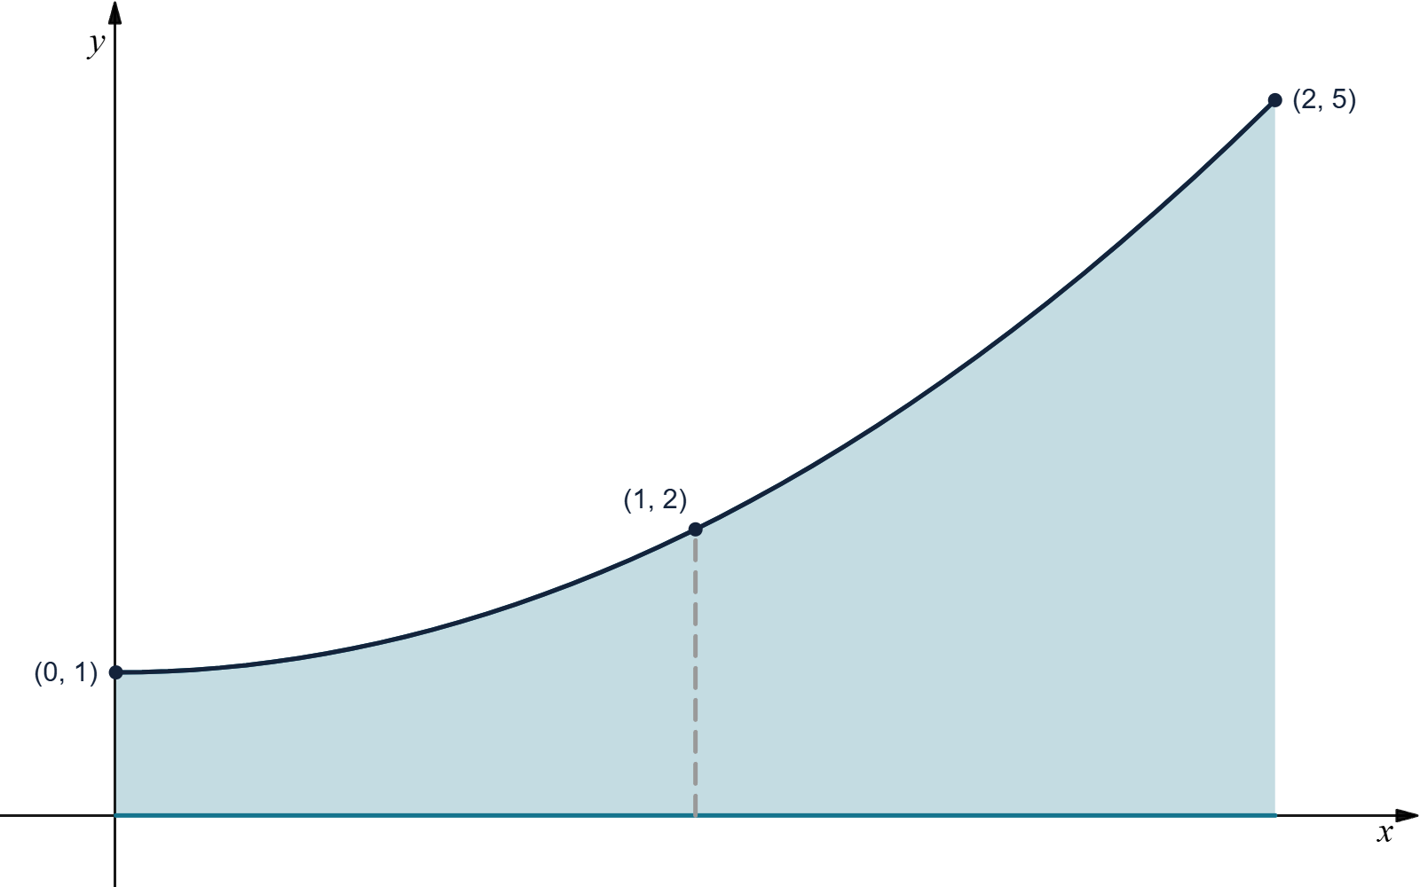
The shaded region lies between $y=x^{2}+1$ and the $x$-axis for $0≤x≤2$, with a divider at $x=1$.

Main solution
Solution
Since $x^{2}+1>0$ for $0≤x≤2$, the shaded area is given by definite integrals of $x^{2}+1$.
For (a), splitting the interval $[0,2]$ at $x=1$ gives
$A=∫_{0}^{1}(x^{2}+1) dx+∫_{1}^{2}(x^{2}+1) dx.$
For (b), an antiderivative is
$∫(x^{2}+1) dx=\frac{x^{3}}{3}+x.$
Therefore,
$\begin{matrix}A & ={[\frac{x^{3}}{3}+x]}_{0}^{1}+{[\frac{x^{3}}{3}+x]}_{1}^{2} \\ & =(\frac{1}{3}+1)−0+(\frac{8}{3}+2)−(\frac{1}{3}+1) \\ & =\frac{4}{3}+\frac{10}{3} \\ & =\frac{14}{3}.\end{matrix}$
Hence, the shaded area is
$\boxed{\frac{14}{3} square units}.$

Proposed marking allocation
(a): Writes the first area integral correctly as $∫_{0}^{1}(x^{2}+1) dx$. [2 marks]
(a): Writes the second area integral correctly as $∫_{1}^{2}(x^{2}+1) dx$, giving the required sum. [2 marks]
(b): Uses the correct antiderivative $\frac{x^{3}}{3}+x$ and substitutes the limits correctly for both definite integrals. [3 marks]
(b): Obtains $A=\frac{14}{3}$ and states the answer in square units. [3 marks]

Reference questions
EXAM AY2025/2026 S1 · A4
EXAM AY2025/2026 S2 · C2
EXAM AY2026/2027 S1 · C2
EXAM AY2024/2025 S2 · C2

